ASSIGNMENT-13.2
NAME:VEMULA RAJEEVKALYAN
HALL TICKET NO:2403A51324
BATCH:13

TASK1:- Provide AI with the following redundant code and ask it to
refactor
Python Code
def calculate_area(shape, x, y=0):
if shape == "rectangle":
return x * y
elif shape == "square":
return x * x
elif shape == "circle":
return 3.14 * x * x
PROMPT:- def calculate_area(shape, x, y=0):
if shape == "rectangle":
return x * y
elif shape == "square":
return x * x
elif shape == "circle":
return 3.14 * x * x rewrite the given code .
Code:-
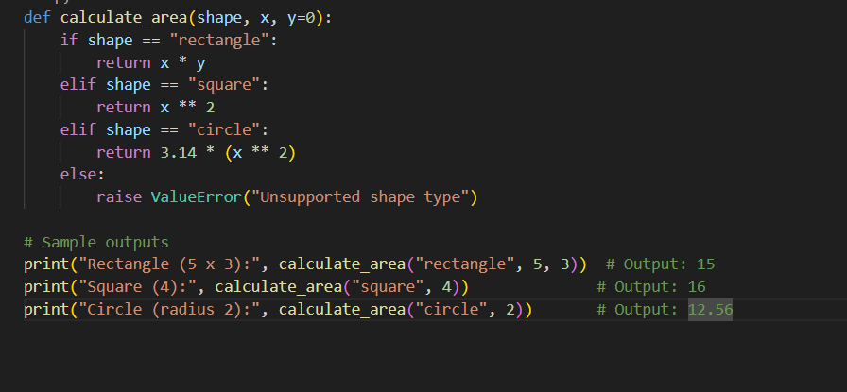
Output:-
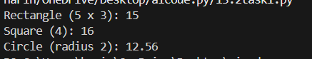
Observation:-
- Used x**2 instead of x*x
- Proper indentation for readability
- Used if else instead of if elif
------------------------------------------------------------------------------------------------------------------------TASK2:-
Legacy function without proper error handling
Python Code:
def read_file(filename):
f = open(filename, "r")
data = f.read()
f.close()
return data
Expected Output:
AI refactors with with open() and try-except
PROMPT:-
def read_file(filename):
f = open(filename, "r")
data = f.read()
f.close()
return data refactor the code using open() and try and except technique.
Code:-
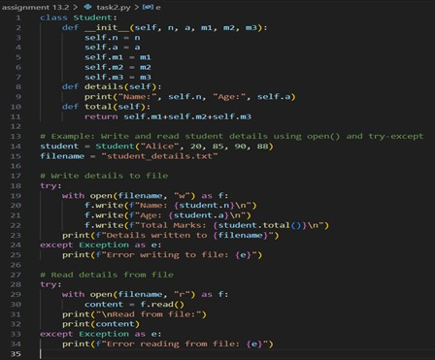
Output:-
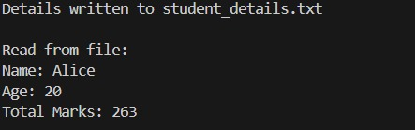
Observation:-
- Create a class student
- Used try and except error handling technique.
- Used try and except to read and write details

------------------------------------------------------------------------------------------------------------------------
TASK3:-
**Provide this legacy class to AI for readability and modularity
improvements:
Python Code
class Student:
def __init__(self, n, a, m1, m2, m3):
self.n = n
self.a = a
self.m1 = m1
self.m2 = m2
self.m3 = m3
def details(self):
print("Name:", self.n, "Age:", self.a)
def total(self):
return self.m1+self.m2+self.m3
Expected Output:
• AI improves naming (name, age, marks).
• Adds docstrings.
• Improves print readability.
• Possibly uses sum(self.marks) if marks stored in a list
PROMPT:-
class Student:
def __init__(self, n, a, m1, m2, m3):
self.n = n
self.a = a
self.m1 = m1
self.m2 = m2
self.m3 = m3
def details(self):
print("Name:", self.n, "Age:", self.a)
def total(self):
return self.m1+self.m2+self.m3 rewrite the code improved naming,readability and add docstrings.
CODE:-
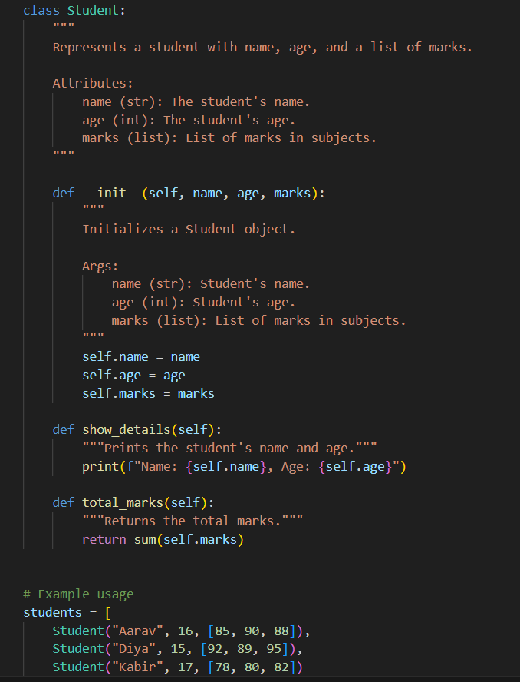
OUTPUT:-
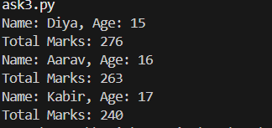
Observation:-
- Added docstrings for readability
- Used descriptive variables for clear understanding of the code

TASK4:- Task: Refactor this inefficient loop with AI help
Python Code
nums = [1,2,3,4,5,6,7,8,9,10]
squares = []
for i in nums:
squares.append(i * i)
Expected Output: AI suggested a list comprehension
PROMPT:-
nums = [1,2,3,4,5,6,7,8,9,10]
squares = []
for i in nums:
squares.append(i * i) fix the errors and rewrite the code with examples.
CODE:-
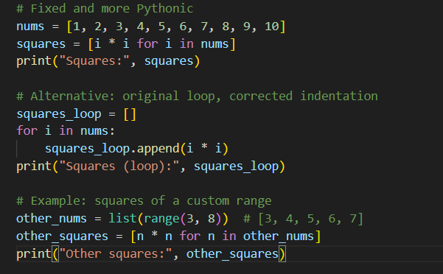
Output:-
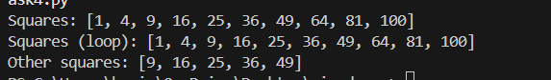
Observation:-
- List comprehension is concise and fast for simple transformations
- the loop version is equivalent
- it makes the list of squares from 1 to 10.
------------------------------------------------------------------------------------------------------------------------------------------------------------------------------------------------------------------------------------------------------------------------------------------------------------------------------------------------------------------------

